**Task 2) Patient Case Summary Workflow**

Task 2:

1/7 🧵🏥 Clinicians are swamped with patient data! 🤯 Imagine automating the creation of patient case summaries to save time & improve care. Let's build a #MedAI workflow using #LlamaIndex! 👇 #HealthTech #AIforGood

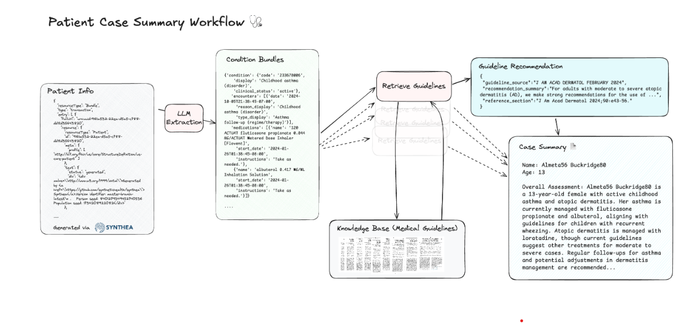

2/7 🧩 Step 1: Data Ingestion. We start with synthetic patient data (using Synthea - realistic!). Our workflow parses this #FHIR data, extracting key info: demographics, conditions, meds, and encounters. 🗂️ #DataEngineering #PatientData

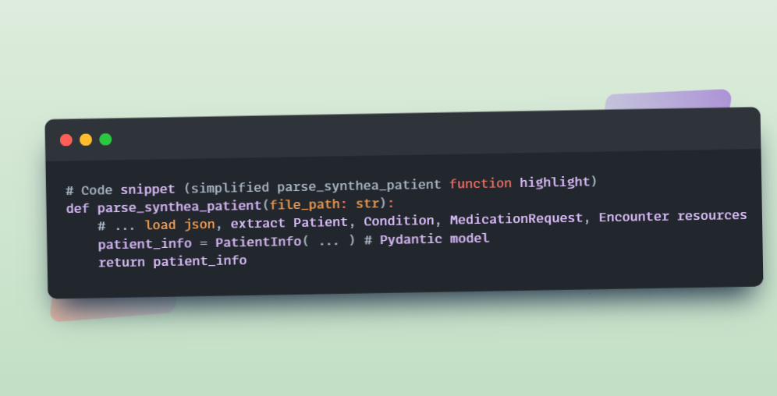

3/7 🧠 Step 2: Condition Bundling with #LLMs. Now the magic! ✨ We use a smart #LLM (like gpt-4o) to group relevant encounters & medications with each active condition. This mimics clinical reasoning! 👩‍⚕️ #NLP #MedicalKnowledge

# LLM intelligently links asthma with asthma follow-up & inhalers

4/7 🔎 Step 3: Guideline Retrieval. To make summaries *clinically useful*, we index medical guidelines (e.g., Asthma Guidelines) using #LlamaCloud (or your fav vector DB!). We generate smart queries (LLM again!) for each condition to fetch relevant guideline sections.

📚 #RAG #VectorSearch #ClinicalGuidelines

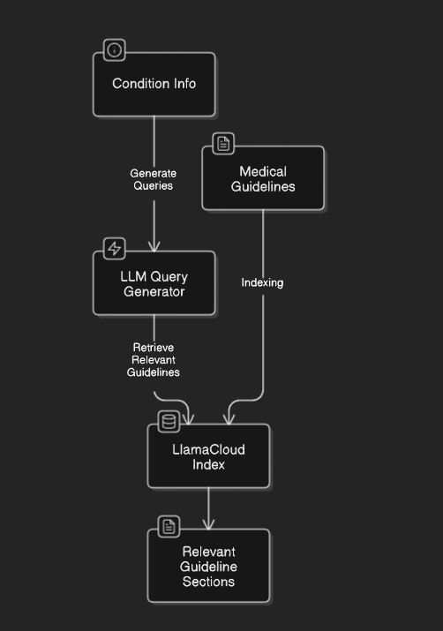

5/7 📝 Step 4: Case Summary Generation. Finally, another #LLM synthesizes everything: patient data + guideline snippets = human-readable case summary!

🚀 Output is structured (JSON using Pydantic CaseSummary model). #GenerativeAI #PatientSummary #WorkflowAutomation

6/7 ⚙️ Workflow Orchestration. This isn't just code snippets! We built a robust, event-driven workflow using #LlamaIndexWorkflow.

Visualize the modularity! 👇

7/7 🎉 Benefits? Faster summaries, improved accuracy, and guideline adherence! This is just the beginning. Imagine scaling this for various conditions & guidelines! Try building your own #MedAI workflows – notebook & code here:

https://github.com/run-llama/llamacloud-demo/blob/main/examples/document_workflows/patient_case_summary/patient_case_summary.ipynb

#OpenSource #HealthcareInnovation #AIforHealth